**Engineering documentation | PAL-ARM Team| Palestine**

This warehouse contains an autonomous vehicle prototype from, Palestine, participating in the WRO Future Engineers competition in the 2023 season. It is an annual competition organized by WRO. It is a nonprofit organization that invests all its returns in supporting such technological competitions. In this year, the tasks concept focuses on designing a self-driving robot according to specific standards using certain equipment. This kind of competition encourages students to invent and solve problems. Therefore, we participate to know more about robots and coding, also to win for the name of our country Palestine.

**Group members**

Adam Jihad Badwan Reem Ismail Albader

Email: [423004928@jsub.edu.ps](mailto:423004928@jsub.edu.ps) Email: [427227954@jsub.edu.ps](mailto:427227954@jsub.edu.ps)

**Repository overview**

* chassis - This folder contains details of the chassis we used
* models - contains 3D printable files designed by us
* schemes - contains electrical system diagrams.
* SRC - contains the main programs and control programs
* photos It contains one serious and one funny photo
* photos Contains images of the robot from all required direction

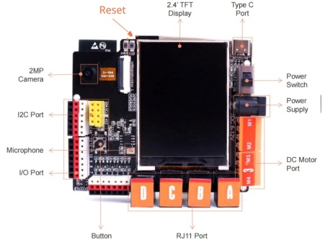**Program arrangement and layout of algorithms:**

The robot works on an ESP32-based development board called the K210 board

made in China. It is used to see red/green obstacles. Ultrasonic is used to avoid crowding within the boundaries of the ring and obstacles, and a timer is programmed to stop in the appropriate place. When the robot is powered on the battery for the first time, it initializes the chip and starts communicating with the HUSKYLENS sensor and IMU. Once it is ready, the servo motor is centered and waits for the user to press the button. The code is then divided into two main parts.

**Part 1:** Complete the run as quickly as possible and stand at the starting point:

In this part, we set the robot's speed to 150 and set the counter to 585 so that (current counter * required speed% required speed = appropriate counter)

**Avoid the wall:**

In the first round, two Ultrasonics measure and compare the distance. If the distance is greater at the ultrasonic (right), the robot moves to the left and vice versa.

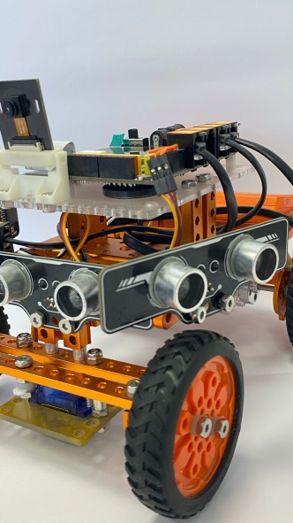

**Ultrasonics**

**Avoid obstacles:**

When the camera detects an object, the K210 panel gets the color of the object. The robot follows the obstacle and then goes around it (follows red and green obstacles). Once it reaches an initial distance of less than 30 cm, it turns the front wheel proportionally to the distance of the object.

**Wall collision protection:**

When the ultrasonic is compared from one side, it rotates the servo in the other direction for a few milliseconds to prevent the robot from crashing into the wall.

**Electrical systems design:**

We carefully selected the best possible parts for our robot after several hundred hours of research and development and tried to achieve the highest efficiency and reliability possible. The design of electrical systems is explained in the following paragraph.

**Design decisions**

During the design, the standards of the World Robotics Olympiad were taken into account so that it does not exceed the permissible dimensions, in addition to making the best design that can maneuver on the track between obstacles, with dimensions that suit the nature of the available pieces. The dimensions were 19 cm width, 23 cm length and 16 cm height.

1) The vehicle's steering wheel movement is designed to simulate the steering wheel of a real car.

2) Rubber-coated wheels were chosen to increase friction force to increase the accuracy of the steering process.

3) We also placed the appropriate wheels to reduce friction and the amount of current required by the servo motor, which operates at a voltage of 5v.

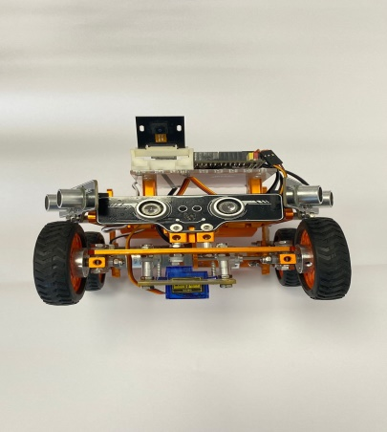

**Servo motor**

4) The diameter of the wheels is somewhat large compared to the size of the vehicle in order to increase its speed.

5) The car’s aluminum frame gives it light weight, which helps reduce energy. Thus, this car can work for a full hour and a half without stopping while maintaining the battery capacity of up to 7.4 WPH

6) Placing heavy batteries in the back of the car to stabilize the car, so that we achieve the greatest reaction force that contributes to increasing the friction force on the wheels responsible for propelling the vehicle.

The following photos describe the car parts**:**

**K210**

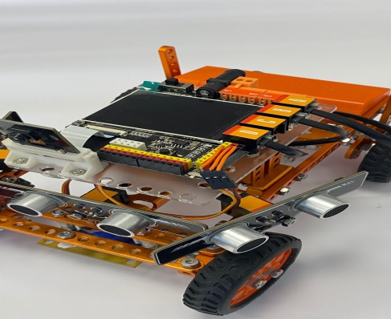

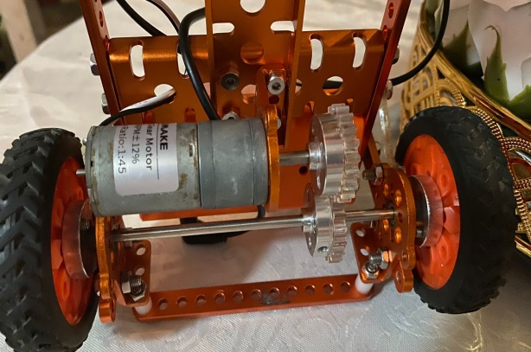

**DC motor**

This code for the first round :

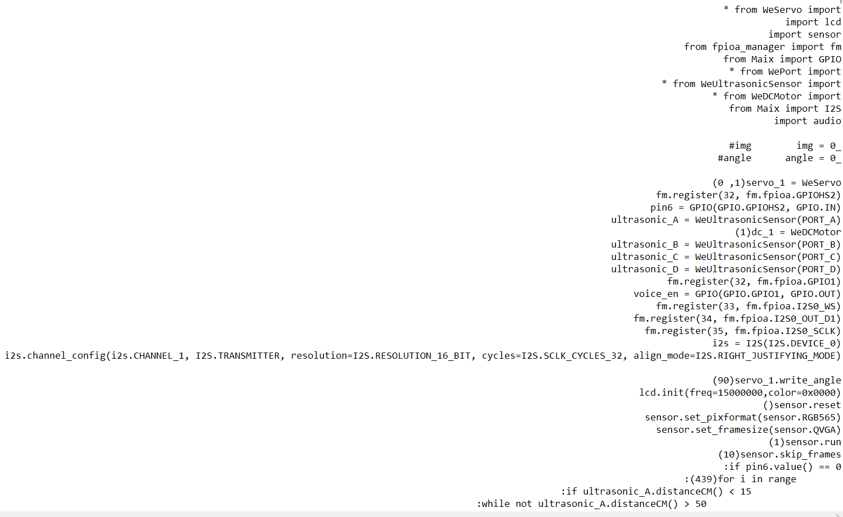

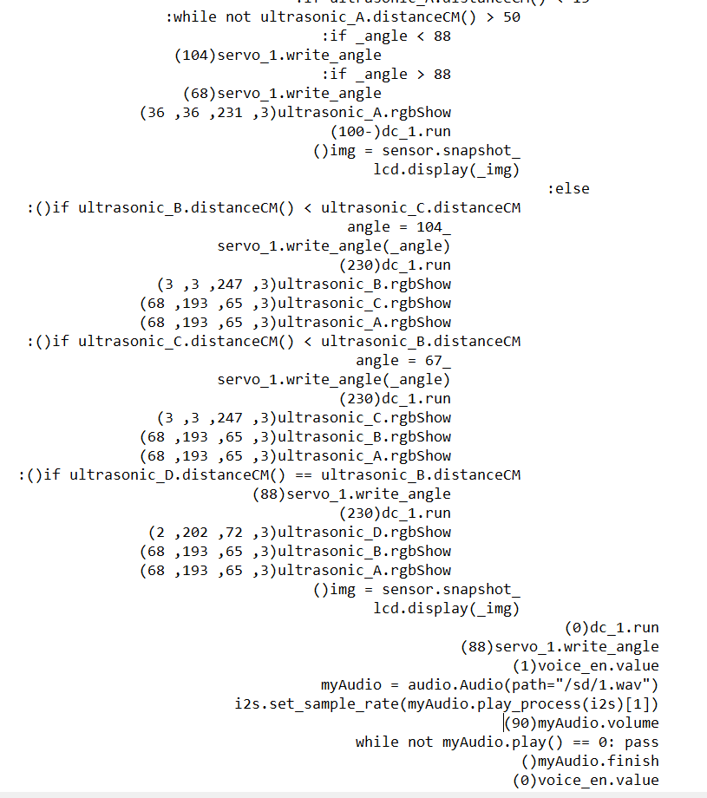

**Repository overview**

* chassis - This folder contains details of the chassis we used
* models - contains 3D printable files designed by us
* schemes - contains electrical system diagrams.
* SRC - contains the main programs and control programs
* photos It contains one serious and one funny photo
* photos Contains images of the robot from all required direction

**Program arrangement and layout of algorithms:**

The robot works on an ESP32-based development board called the K210 board

made in China. It is used to see red/green obstacles. Ultrasonic is used to avoid crowding within the boundaries of the ring and obstacles, and a timer is programmed to stop in the appropriate place. When the robot is powered on the battery for the first time, it initializes the chip and starts communicating with the HUSKYLENS sensor and IMU. Once it is ready, the servo motor is centered and waits for the user to press the button. The code is then divided into two main parts.

**Part 1:** Complete the run as quickly as possible and stand at the starting point:

In this part, we set the robot's speed to 150 and set the counter to 585 so that (current counter * required speed% required speed = appropriate counter)

**Avoid the wall:**

In the first round, two Ultrasonics measure and compare the distance. If the distance is greater at the ultrasonic (right), the robot moves to the left and vice versa.



**Ultrasonics**

**Avoid obstacles:**

When the camera detects an object, the K210 panel gets the color of the object. The robot follows the obstacle and then goes around it (follows red and green obstacles). Once it reaches an initial distance of less than 30 cm, it turns the front wheel proportionally to the distance of the object.

**Wall collision protection:**

When the ultrasonic is compared from one side, it rotates the servo in the other direction for a few milliseconds to prevent the robot from crashing into the wall.

**Electrical systems design:**

We carefully selected the best possible parts for our robot after several hundred hours of research and development and tried to achieve the highest efficiency and reliability possible. The design of electrical systems is explained in the following paragraph.

**Design decisions**

During the design, the standards of the World Robotics Olympiad were taken into account so that it does not exceed the permissible dimensions, in addition to making the best design that can maneuver on the track between obstacles, with dimensions that suit the nature of the available pieces. The dimensions were 19 cm width, 23 cm length and 16 cm height.

1) The vehicle's steering wheel movement is designed to simulate the steering wheel of a real car.

2) Rubber-coated wheels were chosen to increase friction force to increase the accuracy of the steering process.

3) We also placed the appropriate wheels to reduce friction and the amount of current required by the servo motor, which operates at a voltage of 5v.



**Servo motor**

4) The diameter of the wheels is somewhat large compared to the size of the vehicle in order to increase its speed.

5) The car’s aluminum frame gives it light weight, which helps reduce energy. Thus, this car can work for a full hour and a half without stopping while maintaining the battery capacity of up to 7.4 WPH

6) Placing heavy batteries in the back of the car to stabilize the car, so that we achieve the greatest reaction force that contributes to increasing the friction force on the wheels responsible for propelling the vehicle.

The following photos describe the car parts**:**





**DC motor**

**K210**

This code for the first round :



